Davis Ford Animal Hospital
Anesthesia/Surgical Consent Form 13478 Minnieville Road #103
Woodbridge, VA 22192
Phone # (703) 491-5134
Email: davisford101@gmail.com

To help reduce the spread of COVID-19, clients will no longer be allowed in the facility.

Please make sure your pet is on a leash or in a carrier upon arrival or we will not be able to take them from you.

PLEASE FILL OUT THIS FORM AND RETURN PRIOR TO YOUR SCHEDULED SURGERY DATE

When you arrive, please call to check in. After check in, a member of our staff will escort your pet inside. If you have a dog, please wait outside of your vehicle with your leashed dog standing on the ground so our staff can safely apply one of our leashes and you may remove yours with as little human contact as possible. If you have a cat, we ask that you leave your cat in a secure carrier outside the front door for our staff to bring inside safely with as little human contact as possible.

When you return to your scheduled discharge time, we ask that you call from the parking lot to let us know you are here. One of our staff members will discuss home care instructions over the phone and then meet you outside of your vehicle to safely return your dog, if you have a cat, they will be placed right outside the front door.

We care about your pets health as much as we do yours. If you are showing any signs of illness or have been exposed to COVID-19, we ask that you stay home.

CLIENT/PATIENT INFORMATION:
Owner’s Name (First & Last) _____________________________________________
Phone # at which we can reach you ______________________________
Emergency Contact Name and Phone #______________________________________
E-Mail Address ________________________________________________
Pets Name ______________________________
Date of Surgery:_____________________
Surgical procedure(s) to be performed: ⬜ Spay ⬜ Neuter ⬜ Dental ⬜ Mass Removal ⬜ Other:________
If you pet is having a mass removed please circle area on diagram below: 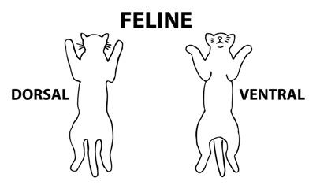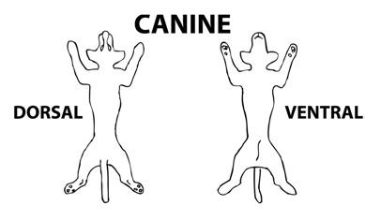
If your pet is having multiple masses removed; please send us a picture of the desired masses to be removed attached to this form.

If your pet is having a spay surgery; when was the last heat cycle or vaginal discharge seen: ______________________

Any issues with vomiting, coughing, diarrhea? ⬜ Yes ⬜ No
If yes please explain:_______________________________________________________________________________ _______________________________________________________________________________________________
Will your pet be taking any medications within 24 hours of scheduled surgery? ⬜ Yes ⬜ No
Which medication(s)? ________________________
When are they given? ________________________
Strength: ____________________________
Dose: ______________________________
Does your pet have any food allergies? ⬜ Yes ⬜ No If yes please explain: _____________________________
I understand that some risks always exist with anesthesia and/ or surgery and that I am encouraged to discuss any concerns I have about those risks with the attending veterinarian before the procedure(s) is/are initiated.
Any concerns or questions regarding the surgical procedure? ⬜ Yes ⬜ No
If yes please explain: _____________________________________________________________________________
_______________________________________________________________________________________________
Pets having surgery will need to be fasted overnight. Please pick up and/or remove any food left out for your pet by 9:00pm the night before surgery. Water can be left out for pets to drink.
I understand and agree: (Initials ______)

PRE-ANESTHETIC TESTING:
A complete physical exam will be performed on your pet prior to the surgical procedure. However, this may not identify all systemic or metabolic problems. For this reason, we require that your pet have pre-anesthetic bloodwork to evaluate major organ functions prior to anesthesia. This blood work consist of:

For pets under 8 yrs old, we require a PCV (pack cell volume) to check for anemia and Chem 10 to check for
kidney, liver and glucose levels.

For pets 8 yrs old and older, we require a CBC to check for anemia, infections and certain blood clotting
problems and Chem 17 to check for kidney, liver, glucose and pancreas levels.

⬜ Blood work done (within 30 days) Date blood work was tested: _________

PAIN MEDICATION:
Pain medication will be given while your pet is here, at the cost of the owner. Pain medication to go home is optional but highly recommended for all surgeries.
I would like pain medication to go home with my pet: ⬜ Yes ⬜ No
MICROCHIP:
Microchipping is a procedure that can be completed at any time, however, due to the large size of the needle used to place the microchip we prefer to do this while your pet is under anesthesia/sedation. Once registered, the chip will be associated with your pet's identity.
Would you like to have your pet microchipped? ⬜ Yes ⬜ No
BIOPSY:
If your pet is having a tumor removed today, would you like a sample to be sent to the lab for a biopsy:
⬜ Yes ⬜ No
I understand that the attending veterinarian will make every effort to contact me regarding treatment in the case of unforeseen emergencies. If unable to contact me, the staff may or may not have my permission to proceed with life sustaining procedures.
I give my permission [Yes]: (Initials ______) I do not give my permission [No]: (Initials _____)

While I accept that all procedures will be performed to the best of the abilities of the staff at this hospital, I understand that no guarantee or warranty has been made regarding the results that may be achieved. I understand the American Veterinary Medical Association recommends dental radiographs to check for pre-existing conditions before extraction and I am aware that this hospital does not perform dental radiographs. I may request a referral to a Board Certified Veterinary Dentist if I wish to have this done.
I understand and agree: (Initials ______)
Please note: Any remaining baby teeth will be removed while the patient is under anesthesia at the cost of the owner. This is done to prevent any future dental problems associated with retained deciduous teeth.

I also assume full responsibility for any additional expenses incurred after the surgical procedure is performed, such as follow up radiographs, re-check physical exams and additional surgery due to post-op complications. These are more likely to occur when there is a failure to comply with the aftercare instructions.

Payment is expected when services are rendered; no billing or payment plans will be implemented without prior approval.

I have read and fully understand the terms and conditions set forth above and I authorize the Doctors of Davis Ford Animal Hospital to prescribe, treat and/or perform surgery as indicated above as well as any procedures deemed necessary for my animals' wellbeing.

Signature of Owner: ____________________________________________________
Date: ________________________________________

